

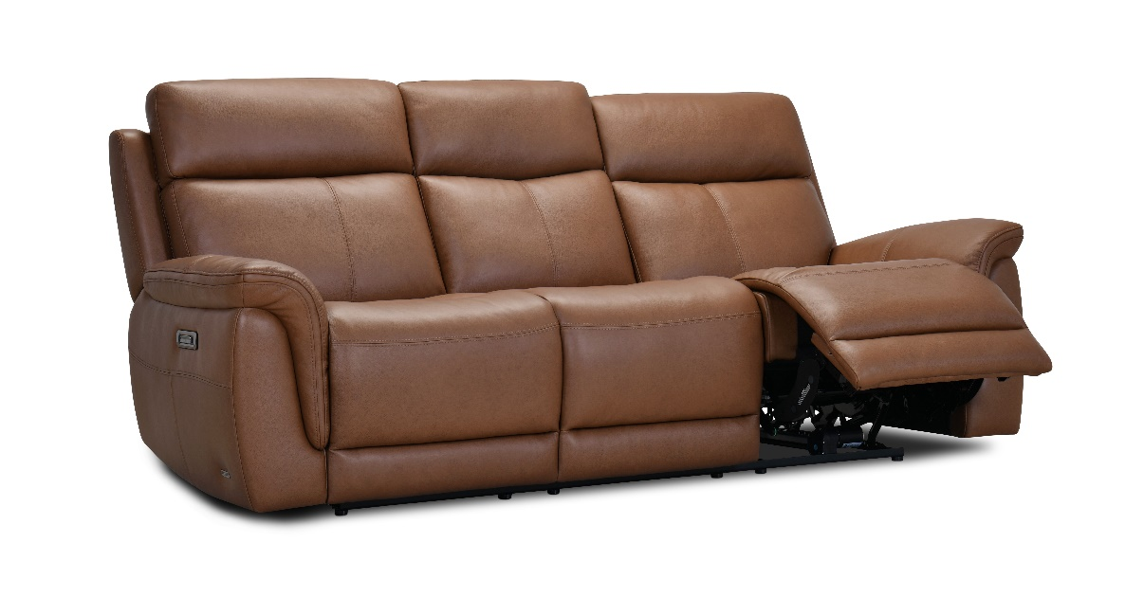

Manhattan

3-Seater Sofa: 2-Seater Sofa: Armchair:
Height: 105cm Height: 105cm Height: 105cm
Width: 225cm Width: 170cm Width: 102cm
Depth: 102cm Depth: 102cm Depth: 102cm

